A Real-time Research Project/Societal Related Project
Report on

NeuroTalkAi
Submitted in Partial fulfillment of requirements for B.Tech II Year II Semester course

By

Names rolls

Under the guidance of

Ms./Mr./Dr.Mentor Name
<Designation>, <Department>



KESHAV MEMORIAL INSTITUTE OF TECHNOLOGY
(AN AUTONOMOUS INSTITUTION)
Accredited by NBA & NAAC, Approved by AICTE, Affiliated to JNTUH.

Narayanaguda, Hyderabad,Telangana-29
2025-26



KESHAV MEMORIAL INSTITUTE OF TECHNOLOGY
(AN AUTONOMOUS INSTITUTION)
Accredited by NBA & NAAC, Approved by AICTE, Affiliated to JNTUH

Narayanaguda, Hyderabad,Telangana-29

CERTIFICATE


This is to certify that this is a bonafide record of the project report titled “NeuroTalkAi”which is being presented as the Real-time Research Project / Societal Related Project report by

Names rolls

In partial fulfillment for the II Year II Semester Course RTRP in KMIT affiliated to the Jawaharlal Nehru Technological University, Hyderabad

Mentors
(Ms/Mr/Dr. XXXX Program Coordinator
(xxxxxxxxxxxxxxxxxxxxxxxxxx)

Submitted for Final Project Review held on ____________________________

Vision& Mission of KMIT

Vision

  - To be the fountain head in producing highly skilled, globally competent engineers.
  - Producing quality graduates trained in the latest software technologies and related tools and striving to make India a world leader in software products and services.

Mission

  - To provide a learning environment that inculcates problem solving skills, professional, ethical responsibilities, lifelong learning through multi model platforms and prepares students to become successful professionals.
  - To establish an industry institute Interaction to make students ready for the industry.
  - To provide exposure to students on the latest hard ware and software tools.
  - Topromoteresearch-basedprojects/activitiesintheemergingareasoftechnologyconvergence.
  - To encourage and enable students to not merely seek jobs from the industry but also to create new enterprises.
  - To induce a spirit of nationalism which will enable the student to develop, understand India's challenges and to encourage them to develop effective solutions.
  - To support the faculty to accelerate their learning curve to deliver excellent service to students.

PROGRAM OUTCOMES(POs)

PO1. Engineering Knowledge: Apply the knowledge of mathematics, science, engineering fundamentals, and an engineering specialization to the solution of complex engineering problems.

PO2. Problem Analysis: Identify formulate, review research literature, and analyze complex engineering problems reaching substantiated conclusions using first principles of mathematics, natural sciences, and engineering sciences


PO3. Design/Development of solutions: Design solutions for complex engineering problems and design system components or processes that meet the specified needs with appropriate consideration for the public health and safety, and the cultural, societal, and environmental considerations.

PO4. Conduct Investigations of Complex problems: Use research-based knowledge and research methods including design of experiments, analysis and inter pretation of data, and synthesis of the information to provide valid conclusions.

PO5. Modern Tool Usage: Create select, and, apply appropriate techniques, resources, and modern engineering and IT tools including prediction and modeling to complex engineering activities with an understanding of the limitations.

PO6. The Engineer and Society: Apply reasoning informed by contextual knowledge to societal, health, safety. Legal und cultural issues and the consequent responsibilities relevant to professional engineering practice.

PO7. Environment and Sustainability: Understand the impact of the professional engineering solutions in societal and environmental contexts and demonstrate the knowledge of, and need for sustainable development.
PO8. Ethics: Apply ethical principles and commit professional ethics and responsibilities and norms of the engineering practice.
PO9. Individual and Team Work: Function effectively as an individual, and as a member or leader in diverse teams and in multidisciplinary settings.

PO10. Communication: Communicate effectively on complex engineering activities with the engineering community and with societ yat large, such as, being able to comprehend and write effective reports and design documentation, make effective presentations, and give and receive clear instructions.

PO11. Project Management and Finance: Demonstrate knowledge and understanding of the engineering and management principles and apply these to one's own work, as a member and leader in a team, to manage projects and in multi disciplinary environments.


PO12. Life-Long Learning: Recognize the need for, and have the preparation and abilitytoengageinindependentandlife-longlearninginthebroadestcontextoftechnological change.

PROJECT OUTCOMES

P1: Write Your Project Outcomes Here
P2: Write Your Project Outcomes Here
P3: Write Your Project Outcomes Here
P4: Write Your Project Outcomes Here

MAPPING PROJECTOUTCOMESWITH PROGRAMOUTCOMES

PO | PO1 | PO2 | PO3 | PO4 | PO5 | PO6 | PO7 | PO8 | PO9 | PO10 | PO11 | PO12
P1
P2
P3
P4

L– LOW M –MEDIUM H– HIGH

DECLARATION


We hereby declare that the results embodied in the dissertation entitled “<Title>”has been carried out by us together during the academic year2024-25 as a partial fulfillment of the B.Tech II Year II Semester Course “Real-time Research Project / Societal Related Project”. We have not submitted this report to any other Course/College.

Student Name Roll no.

Names rools

ACKNOWLEDGEMENT
We take this opportunity to thank all the people who have rendered their full support to our project work. We render our thanks to Dr. B L Malleswari, Principal who encouraged us to do the Project.

We are grateful to Mr. Neil Gogte, Founder & Director and Mr. S. Nitin, Director, for facilitating all the amenities required for carrying out this project.

We express our sincere gratitude to Ms. Deepa Ganu, Academic Director for providing an excellent environment in the college.

We are also thankful to mentors Program Coordinator for providing us with time to make this project a success within the given schedule.

We are also thankful to our Project Mentor Ms. XXXX / Mr. XXX, for her/his valuable guidance and encouragement given to us throughout the project work.

We would like to thank the entire KMIT faculty, who helped us directly and indirectly in the completion of the project.

We sincerely thank our friends and family for their constant motivation during the project work.

Student Name Roll no.

Name rools

ABSTRACT

YOUR PROJECT ABSTRACT SHOUL BE HERE
In this project, a prototype and implementation of Home Appliances is demonstrated. The proposed system consists of a Hardware interface and Software interface. Hardware interface includes Raspberry Pi, lights, fans, DC motor and software interface includes IOT supporteddashboardplatform.WeautomatelightsandfansusingmotionsensorslikeIRsensorsorwecan use an IOT based dashboard for operating fans and lights. A Raspberry Pi is used for controlling home appliances and sensors. An application is provided for controlling multiple home appliances. This system is one of the best methods for controlling home devices with easewith multiple users and one of the best methods for an energy management system. This XXXXXXXXXXXXXXXXXXXXXXXXXXXXXXXXXXXXXXXXXXXXXXXXXXX

LISTOFFIGURES

S.No | Name of Screenshot | Page No.
1.
2.
3.
4.
5.

CONTENTS

DESCRIPTION PAGECHAPTER-1 1
  - INTRODUCTION 2-4
    - Purpose of the project 2
    - Problem with Existing Systems 2
    - Proposed System 3
    - Scope of the Project 3
    - Architecture Diagram 4
CHAPTER–2 5
  - LITERATURESURVEY 6-7
CHAPTER-3 8
  - SOFTWAREREQUIREMENTSPECIFICATION9-12
    - Introduction to SRS 9
    - Role of SRS 9
    - Requirements Specification Document 10
    - Functional Requirements 10
    - Non-Functional Requirements 11
    - Performance Requirements 11
    - Software Requirements 11
    - Hardware Requirements 12
CHAPTER–4 13
  - SYSTEMDESIGN 14-30
    - Introduction to UML 14

    - UML Diagrams 15
      - Use Case Diagram 15
      - Sequence Diagram 18
      - State Chart Diagram 19
      - Deployment Diagram 20
    - TECHNOLOGIESUSED 21
CHAPTER–5 32
  - IMPLEMENTATION 33-42
    - Setting up connections with Raspberry PI 33
    - Coding the logic 35
    - Connecting the dashboard 40
    - Screenshots 42
    - UI Screen shots 43
CHAPTER–6 44
  - SOFTWARETESTING 45-51
    - Introduction 45
      - Testing Objectives 45
      - Testing Strategies 45
      - System Evaluation 48
      - Testing New System 49
    - Test Cases 50
CONCLUSION 52
FUTUREENHANCEMENTS 53
REFERENCES 54
BIBLIOGRAPHY 55

CHAPTER-1

INTRODUCTION

NeuroTalk AI is an advanced emotional analytics platform designed to

detect and analyze human emotions from text and emojis using Artificial Intelligence. The system utilizes transformer-based Natural Language Processing (NLP) models to classify multiple emotions with confidence scores in real time.

The project is implemented as a full-stack application consisting of a React-based frontend, FastAPI backend, and MongoDB database. The backend processes user input and interacts with a trained deep learning model to predict emotional states. The frontend provides an interactive dashboard for visualizing emotional insights.

Additionally, the system includes a secure authentication mechanism with system-generated 4-digit passwords and maintains user history for tracking emotional patterns. The application aims to provide awareness about mental and emotional states and can be used in fields such as mental health monitoring, social media analysis, and user behavior understanding.

This project demonstrates the integration of AI, web technologies, and database systems to build a real-time intelligent application.

🔹 Purpose of the Project

The main purpose of this project is to develop an intelligent system that can detect and analyze human emotions from textual input and emojis in real time. The system aims to help users understand their emotional patterns and provide insights into their mental state using AI-based analysis.

🔹 Problem with Existing Systems

Existing systems for emotion detection are often limited to basic sentiment analysis such as positive, negative, or neutral classification. These systems lack the ability to detect multiple emotions simultaneously and do not support emoji-based analysis.

Additionally, most traditional systems do not provide real-time processing, interactive dashboards, or personalized tracking. They also lack proper integration between frontend, backend, and database systems.

🔹 Proposed System

The proposed system, BolMitra – NeuroTalk AI, is a real-time emotional analytics platform that overcomes the limitations of existing systems. It uses transformer-based NLP models to detect multiple emotions from both text and emojis.

The system provides a modern user interface with an interactive dashboard, secure authentication using a 4-digit code, and stores user emotional history in a database. It integrates frontend, backend, and AI model components to deliver a complete full-stack solution.

🔹 Scope of the Project

The scope of this project includes emotion detection, visualization, and tracking using AI technologies. The system can be used in applications such as mental health awareness, social media monitoring, and user behavior analysis.

Future scope includes adding voice-based emotion detection, improving model accuracy, and deploying the system on cloud platforms for wider accessibility.

🔹 Architecture Diagram

The system follows a full-stack architecture consisting of three main layers: frontend, backend, and database.

The frontend is developed using React (Vite) and provides the user interface for interaction. The backend is implemented using FastAPI, which handles API requests and processes input data. The AI model is integrated into the backend for emotion prediction.

The MongoDB database stores user data and emotional history. The frontend communicates with the backend through REST APIs, and the backend interacts with the database and model to generate results.

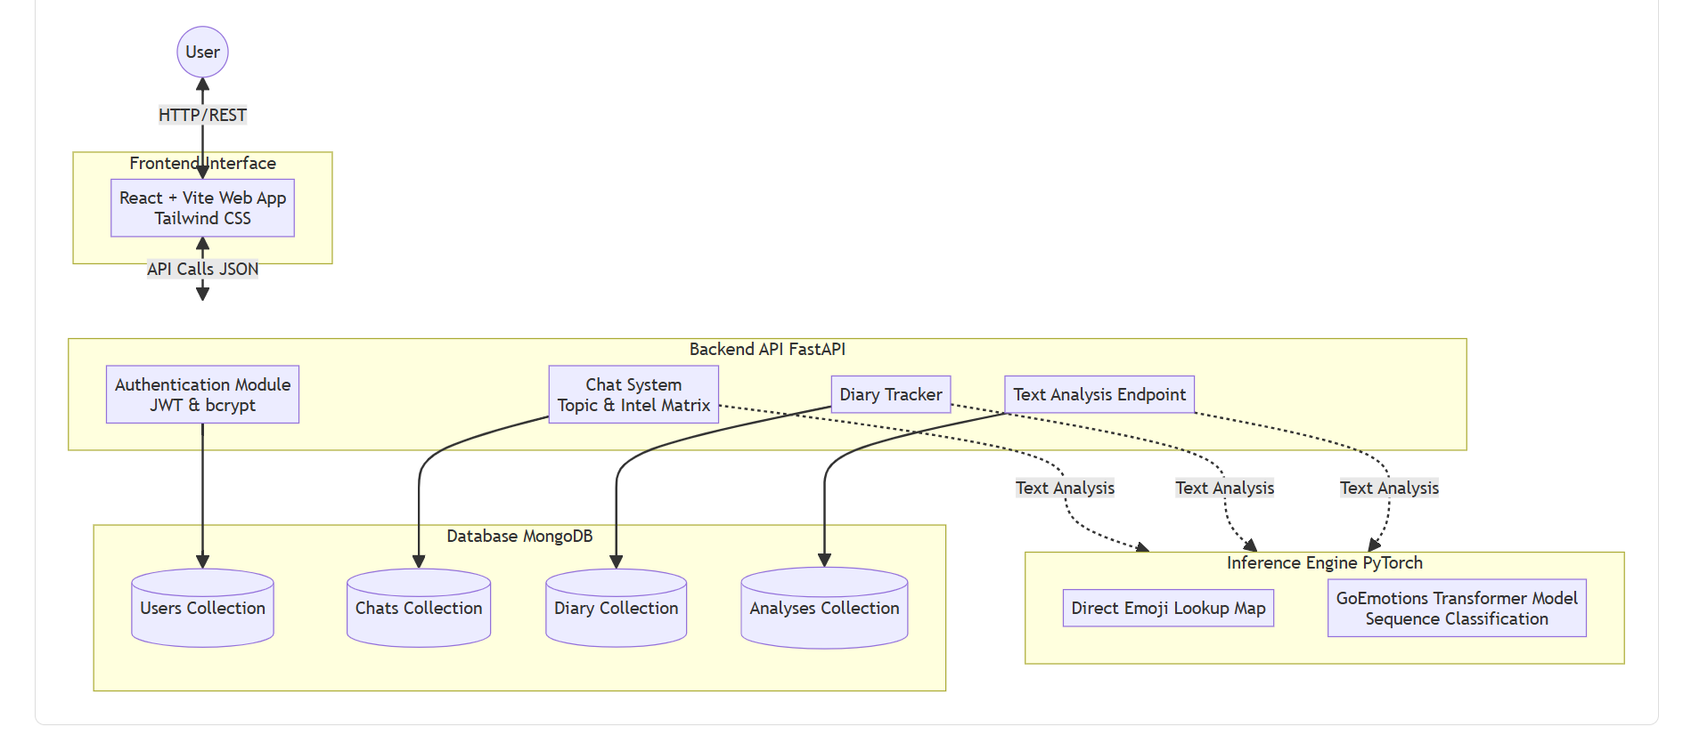

CHAPTER 2 – LITERATURE SURVEY

Recent advancements in Natural Language Processing (NLP) have significantly improved the ability to analyze human emotions from text. Traditional machine learning approaches relied on feature extraction techniques such as Bag of Words and TF-IDF, which lacked contextual understanding.

With the introduction of transformer-based models such as BERT (Bidirectional Encoder Representations from Transformers) and DistilBERT, emotion detection systems have achieved higher accuracy and better contextual interpretation. These models analyze text by understanding the relationship between words in a sentence rather than treating them independently.

Several research works have explored multi-label emotion classification, where a single input can represent multiple emotional states. This approach is more realistic compared to single-label classification because human emotions are often complex and overlapping.

In addition, emoji-based emotion detection has gained importance due to the widespread use of emojis in digital communication. Emojis provide additional emotional context that text alone may not convey.

Existing systems mainly focus on sentiment analysis or limited emotion detection. However, there is a growing need for systems that integrate text and emoji analysis while providing real-time results and user interaction.

The proposed system builds upon these advancements by combining transformer-based models, multi-label classification, and full-stack development to create an efficient and scalable emotional analytics platform.

CHAPTER 3 – SRS

Introduction to SRS

The Software Requirement Specification (SRS) document defines the complete functional and non-functional requirements of the BolMitra – NeuroTalk AI system. It acts as a blueprint for system development, ensuring that all components work together efficiently. The SRS helps developers, testers, and stakeholders understand the system behavior before implementation.

Role of SRS

The SRS plays a critical role in:

Clearly defining system objectives

Avoiding misunderstandings during development

Serving as a reference for testing and validation

Helping in project planning and estimation

It ensures that the system meets both user expectations and technical requirements.

Requirements Specification Document

Functional Requirements

The system should:

Accept textual input from the user

Accept emoji-based input

Process input using NLP models

Detect multiple emotions simultaneously

Display emotion results with confidence levels

Allow users to register and login

Generate a 4-digit authentication code

Store user emotional history in database

Display past results in dashboard

Provide real-time responses

Non-Functional Requirements

The system must be user-friendly

The system should respond within 2 seconds

The system should handle multiple users

The system must be secure

The system should be scalable for future expansion

Performance Requirements

Fast API response time

Efficient memory usage

Low latency in emotion prediction

High accuracy of NLP model

Software Requirements

Python (Backend logic)

FastAPI (API framework)

React (Frontend UI)

MongoDB (Database)

PyTorch & Transformers (AI model)

Node.js (Frontend dependency manager)

Hardware Requirements

Minimum 4GB RAM

Intel i3 or above processor

Internet connection

System capable of running Python and Node.js

CHAPTER 4 – TECHNOLOGIES USED

Introduction to UML

Unified Modeling Language (UML) is used to visualize the system architecture and workflows. It helps in understanding system design clearly before implementation.

Use Case Diagram

Actors:

User

Use Cases:

Register

Login

Enter text/emojis

View emotion results

View history

Explanation:
The user interacts with the system by entering text or emojis. The system processes input and displays emotional results.

Sequence Diagram

Steps:

User enters input

Frontend sends request to backend

Backend processes request

AI model predicts emotions

Database stores results

Backend sends response

Frontend displays results

State Chart Diagram

States:

Idle

Input Received

Processing

Result Generated

Display Output

This diagram represents transitions between system states.

Deployment Diagram

Components:

Client (Browser)

Frontend Server (React)

Backend Server (FastAPI)

Database Server (MongoDB)

AI Model Server

TECHNOLOGIES USED

Frontend (React)

React is used to build an interactive user interface. It provides fast rendering and component-based architecture.

Backend (FastAPI)

FastAPI is used for handling API requests. It is fast, efficient, and supports asynchronous operations.

Database (MongoDB)

MongoDB stores user data and emotional history. It is a NoSQL database that supports flexible data structures.

AI Model (DistilBERT)

DistilBERT is a transformer-based NLP model used for emotion detection. It provides high accuracy with reduced computational cost.

CHAPTER 5 – IMPLEMENTATION

The implementation of the system involves integrating frontend, backend, and AI model components. The backend is developed using FastAPI and includes APIs for handling user requests and processing data.

The AI model processes input text and predicts emotions using trained datasets. The frontend communicates with the backend through APIs and displays results in a user-friendly dashboard.

MongoDB is used to store user credentials and emotional history. The system also includes authentication functionality using a 4-digit password mechanism.

Setting up connections

The backend is connected to MongoDB using a database client. The AI model is loaded into memory for processing input.

Coding the logic

The backend logic includes:

Receiving user input

Preprocessing text

Passing input to AI model

Getting emotion predictions

Sending response to frontend

Connecting the dashboard

Frontend communicates with backend APIs using HTTP requests. The results are displayed dynamically using React components.

Screenshots

Login page
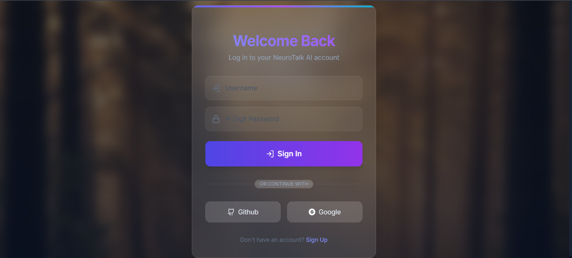

Dashboard

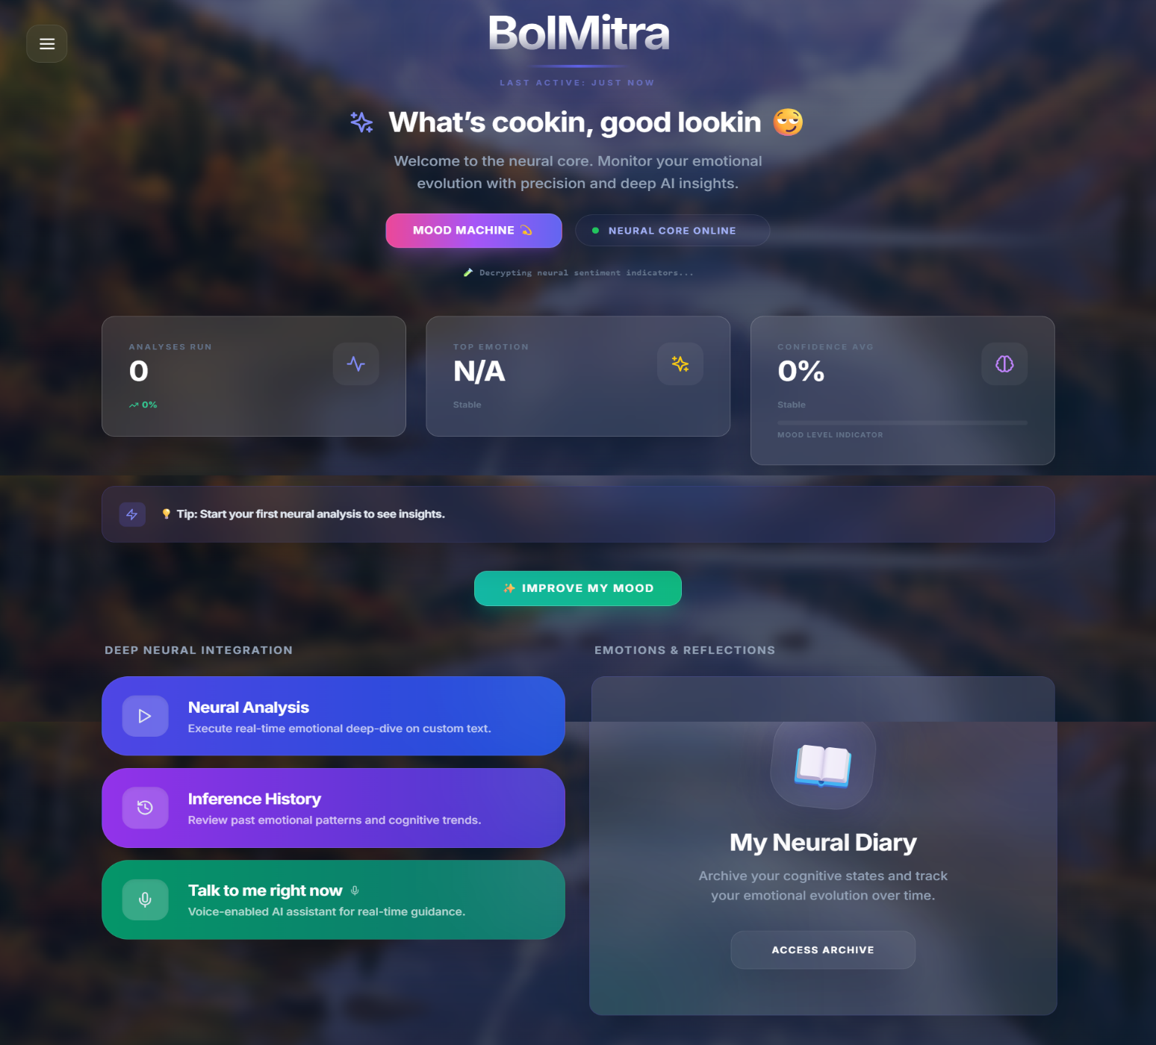
- 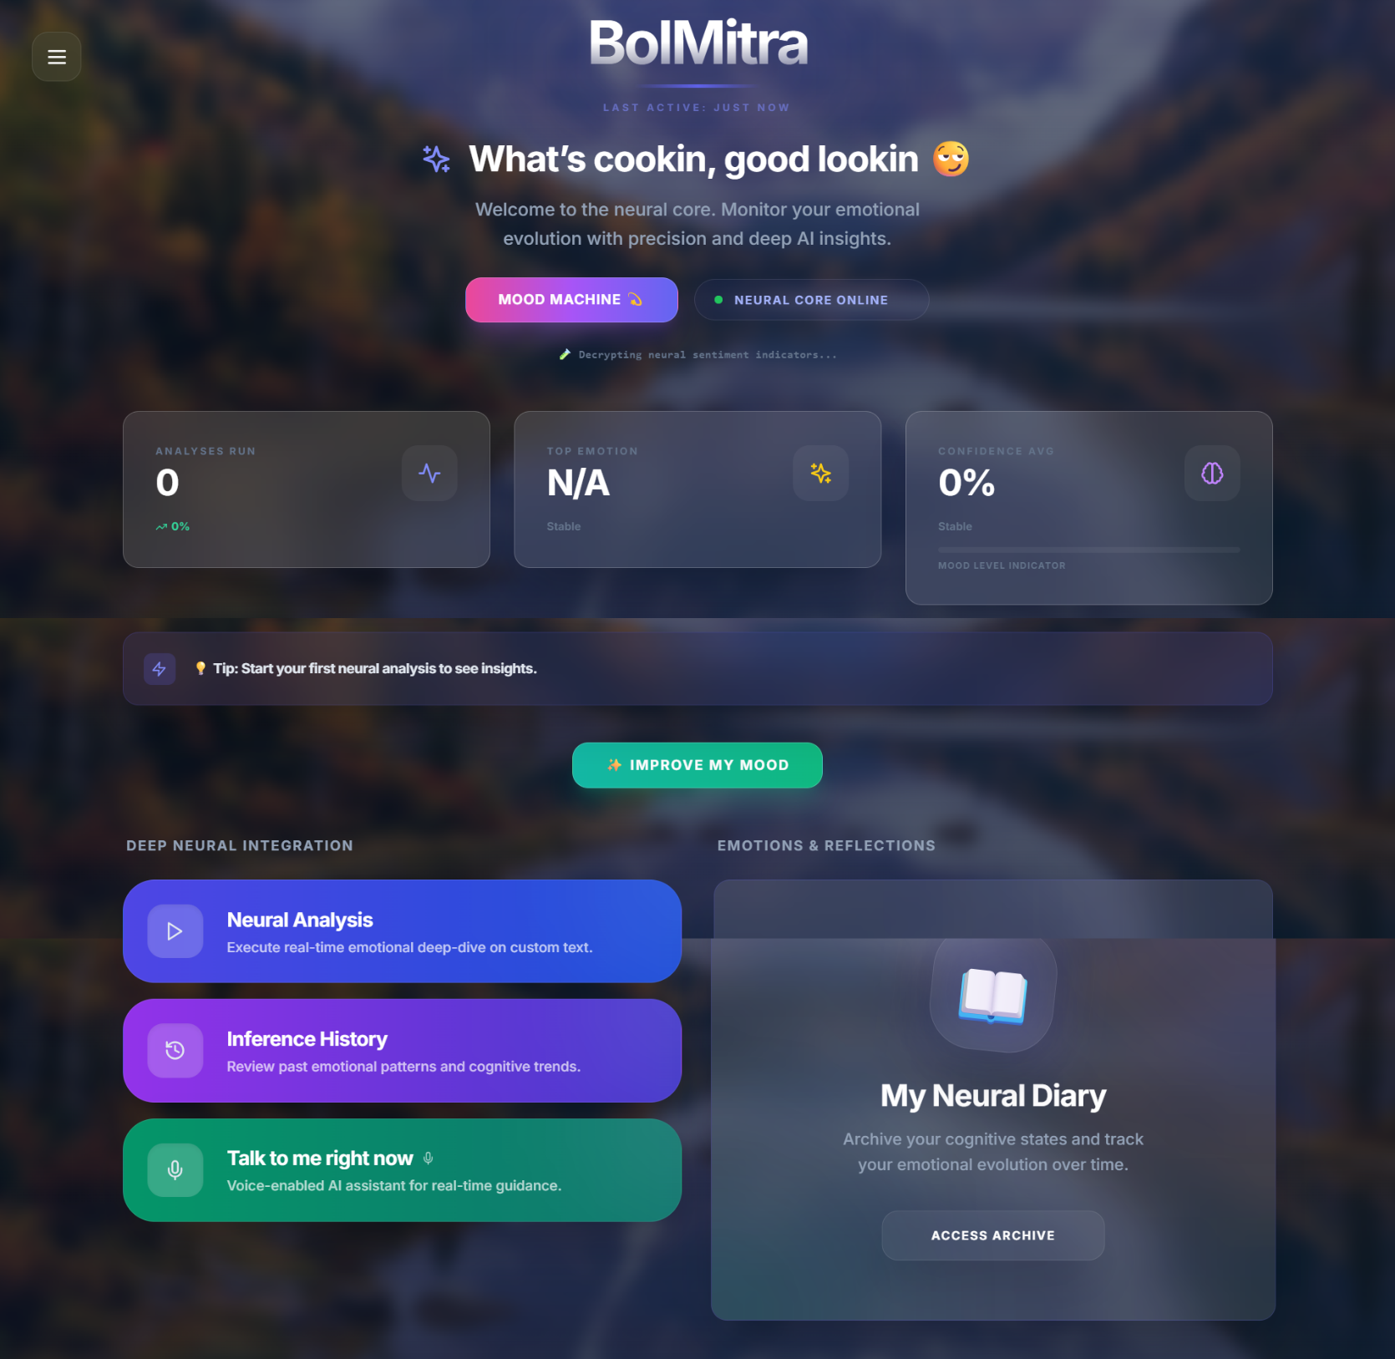

Emotion result screen

History page

CHAPTER 6 – SOFTWARE TESTING

Introduction

Software testing ensures the system works correctly and meets requirements.

Testing Objectives

Validate system functionality

Ensure accuracy of predictions

Check performance under load

Testing Strategies

Unit Testing → Testing individual modules

Integration Testing → Testing module interaction

System Testing → Testing complete system

System Evaluation

The system is evaluated based on:

Accuracy

Response time

User experience

Testing New System

The system was tested with:

Different text inputs

Emoji combinations

Edge cases

Test Cases

Example:
Input: "I feel happy 😊"
Output: Happiness (Confidence: High)

Input: "I am sad 😢"
Output: Sadness

CONCLUSION

NeuroTalk AI system successfully demonstrates the application of AI in emotional analysis. The system integrates NLP, web technologies, and database systems to provide a real-time emotion detection platform.

It enhances user awareness of emotional patterns and provides a scalable solution for future improvements.

FUTURE ENHANCEMENTS

- Voice-based emotion detection

- Improved model accuracy

- Cloud deployment

- Advanced analytics dashboard

- Mobile application support

REFERENCES

NLP Research Papers

FastAPI Documentation

React Documentation

MongoDB Documentation

HuggingFace Transformers

BIBLIOGRAPHY

AI textbooks

Online tutorials

Research articles

